**GURU NANAK COLLEGE BUDHLADA**



**DEPARTMENT: COMPUTER**

**NAME OF PROJECT: image To ASCII**

Submitted to: Submitted by:

HOD **Chushamdeep Singh(1103)**

**Dr. Rekha Kalra Yash(1145)**

**Munish Kumar(1130)**

Table of Contents

**1. Introduction 2**

**2. Functionality 4**

**3. Code Explanation 5**

**Class Structure 5**

**Methods 5**

**CODE 5**

**4. Usage Guide 11**

**5. OUTPUT 12**

**OUPTUT 1 12**

**OUTPUT 2 13**

**6. LICENSE 14**

# 1. Introduction

The Image to ASCII Art Converter is a Java-based application that converts images into ASCII art. It provides a graphical user interface (GUI) for users to

* open an image file
* adjust settings such as
* pixel size
* Width-Height
* And view the resulting ASCII representation of the image.

**Project repository** [(https://github.com/dullat)](https://github.com/dullat/java-project-ASCIIart)

**Preview: 1**

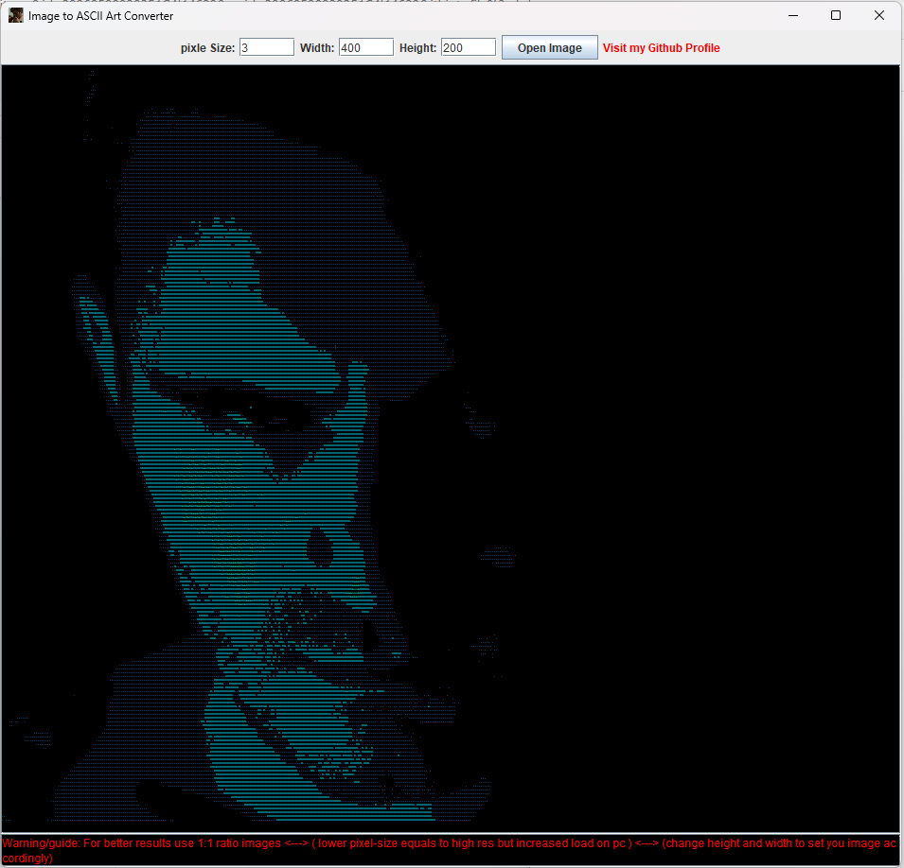

# 2. Functionality

The main functionality of the application includes:

* Opening an image file using a file chooser dialog.
* Adjusting pixel size, width, and height of the output ASCII art.
* Displaying the ASCII representation of the image in a text area.
* Providing warnings and guidance for optimal results.

**Preview 2:**

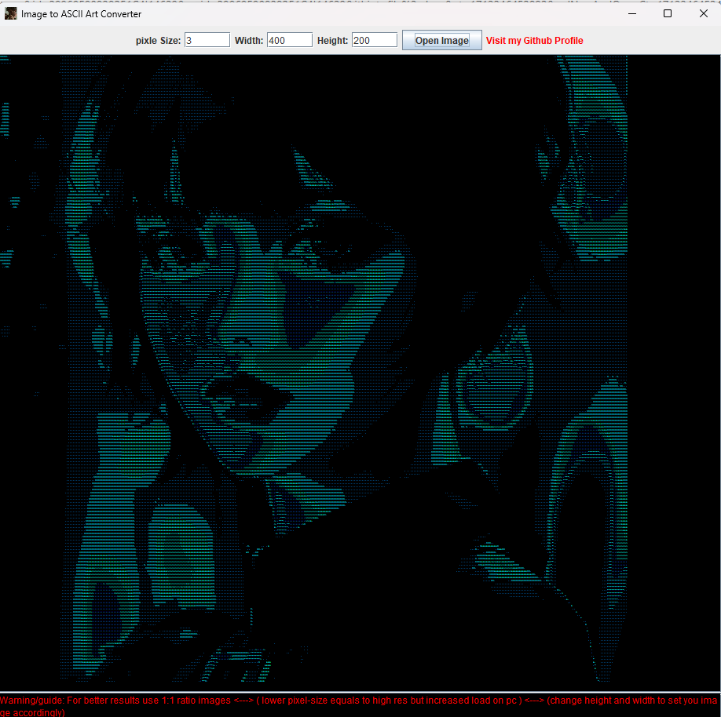

# 3. Code Explanation

## **Class Structure**

* **ImageToAsciiGUI**: The main class representing the GUI application. It extends **JFrame** and contains components for user interaction.

## **Methods**

* **openImage()**: Opens a file chooser dialog to select an image file, reads the selected image, and generates ASCII art from it.
* **updateFontSize()**: Updates the font size of the ASCII art based on user input.
* **generateAsciiArt(BufferedImage image)**: Generates ASCII art from a given image.
* **resize(BufferedImage image, int width, int height)**: Resizes an image to a specified width and height.
* **mapToAscii(int gray)**: Maps a grayscale value to an ASCII character.
* **displayMessage(String message)**: Displays a message in the message area of the GUI.
* **clearMessage()**: Clears the message area.
* **main(String[] args)**: Entry point of the application, invoking the GUI creation.

## **CODE**

import javax.imageio.ImageIO;

import javax.swing.*;

import java.awt.*;

import java.awt.image.BufferedImage;

import java.io.File;

import java.io.IOException;

import java.net.URI;

import java.awt.event.*;

public class ImageToAsciiGUI extends JFrame {

private JTextArea asciiTextArea;

private JTextField fontSizeTextField;

private JTextField widthTextField;

private JTextField heightTextField;

private JTextArea messageArea;

public ImageToAsciiGUI() {

setTitle("Image to ASCII Art Converter");

setSize(800, 600);

setDefaultCloseOperation(JFrame.EXIT_ON_CLOSE);

JPanel contentPane = new JPanel();

contentPane.setLayout(new BorderLayout());

contentPane.setBackground(Color.BLACK);

asciiTextArea = new JTextArea();

asciiTextArea.setEditable(false);

asciiTextArea.setFont(new Font("Monospaced", Font.PLAIN, 3));// default pixl size to 3

asciiTextArea.setForeground(Color.CYAN); // setting color to aqua

asciiTextArea.setBackground(Color.BLACK);// setting bg

JScrollPane scrollPane = new JScrollPane(asciiTextArea);

// pixelsize label and text field

JLabel fontSizeLabel = new JLabel("pixle Size:");

fontSizeTextField = new JTextField("3", 5); // Default font size

fontSizeTextField.addActionListener(e -> updateFontSize());

JLabel widthLabel = new JLabel("Width:");

widthTextField = new JTextField("400", 5); // Default width

JLabel heightLabel = new JLabel("Height:");

heightTextField = new JTextField("200", 5); // Default height

//image button

JButton openImageButton = new JButton("Open Image");

openImageButton.addActionListener(e -> openImage());

// control panel

JPanel controlPanel = new JPanel();

controlPanel.add(fontSizeLabel);

controlPanel.add(fontSizeTextField);

controlPanel.add(widthLabel);

controlPanel.add(widthTextField);

controlPanel.add(heightLabel);

controlPanel.add(heightTextField);

controlPanel.add(openImageButton);

//warnings

messageArea = new JTextArea("Warning/guide: For better results use 1:1 ratio images <---> ( lower pixel-size equals to high res but increased load on pc ) <---> (change height and width to set you image accordingly)");

messageArea.setEditable(false);

messageArea.setForeground(Color.RED);

messageArea.setBackground(Color.BLACK);

messageArea.setLineWrap(true);

JScrollPane messageScrollPane = new JScrollPane(messageArea);

contentPane.add(scrollPane, BorderLayout.CENTER);

contentPane.add(controlPanel, BorderLayout.NORTH);

contentPane.add(messageScrollPane, BorderLayout.SOUTH);

setContentPane(contentPane);

setVisible(true);

// setting logo

try {

BufferedImage iconImage = ImageIO.read(getClass().getResourceAsStream("profile.png"));

// BufferedImage iconImage = ImageIO.read(new File("profile.png"));

setIconImage(iconImage);

} catch (IOException ex) {

System.out.println("cant load image: " + ex.getMessage());

}

//github link

JLabel githubLink = new JLabel("Visit my Github Profile");

githubLink.setCursor(new Cursor(Cursor.HAND_CURSOR));

githubLink.setForeground(Color.RED);

githubLink.addMouseListener(new MouseAdapter() {

@Override

public void mouseClicked(MouseEvent e) {

try {

Desktop.getDesktop().browse(new URI("https://github.com/dullat"));

} catch (Exception ex) {

ex.printStackTrace();

}

}

});

controlPanel.add(githubLink);

}

private void openImage() {

JFileChooser fileChooser = new JFileChooser();

int returnValue = fileChooser.showOpenDialog(this);

if (returnValue == JFileChooser.APPROVE_OPTION) {

File selectedFile = fileChooser.getSelectedFile();

try {

BufferedImage image = ImageIO.read(selectedFile);

String asciiArt = generateAsciiArt(image);

asciiTextArea.setText(asciiArt);

//clearMessage();// clear warning message. disabled

} catch (IOException ex) {

ex.printStackTrace();

displayMessage("Error: selectedfile is not valid.");

}

}

}

private void updateFontSize() {

try {

int fontSize = Integer.parseInt(fontSizeTextField.getText());

asciiTextArea.setFont(new Font("Monospaced", Font.PLAIN, fontSize));

//clearMessage(); // Clear any previous messages

} catch (NumberFormatException ex) {

displayMessage("enter a valid font size.");

}

}

private String generateAsciiArt(BufferedImage image) {

StringBuilder asciiArt = new StringBuilder();

int asciiWidth = Integer.parseInt(widthTextField.getText());

int asciiHeight = Integer.parseInt(heightTextField.getText());

BufferedImage resizedImage = resize(image, asciiWidth, asciiHeight);

for (int y = 0; y < asciiHeight; y++) {

StringBuilder asciiRow = new StringBuilder();

for (int x = 0; x < asciiWidth; x++) {

int pixel = resizedImage.getRGB(x, y);

int gray = (getRed(pixel) + getGreen(pixel) + getBlue(pixel)) / 4;

char asciiChar = mapToAscii(gray);

asciiRow.append(asciiChar);

}

asciiArt.append(asciiRow).append("\n");

}

return asciiArt.toString();

}

private BufferedImage resize(BufferedImage image, int width, int height) {

BufferedImage resizedImage = new BufferedImage(width, height, BufferedImage.TYPE_INT_RGB);

Graphics2D g = resizedImage.createGraphics();

g.drawImage(image, 0, 0, width, height, null);

g.dispose();

return resizedImage;

}

private int getRed(int rgb) {

return (rgb >> 16) & 0xFF;

}

private int getGreen(int rgb) {

return (rgb >> 8) & 0xFF;

}

private int getBlue(int rgb) {

return rgb & 0xFF;

}

private char mapToAscii(int gray) {

char[] asciiChars = {' ', '.', '8', '&', 'o', ':', '*', '.', ' '}; // ASCII characters working as Pixles

int index = (int) (gray * ((asciiChars.length - 1) / (255.0 * 0.7)));

return asciiChars[index];

}

private void displayMessage(String message) {

messageArea.setText(message);

}

private void clearMessage() {

messageArea.setText("");

}

public static void main(String[] args) {

SwingUtilities.invokeLater(ImageToAsciiGUI::new);

}

}

# 4. Usage Guide

To use the Image to ASCII Art Converter:

* Launch the application by running the main method.
* Click on the "Open Image" button to select an image file.
* Adjust the pixel size, width, and height settings as desired.
* View the resulting ASCII art in the text area.
* For optimal results, follow the provided warnings and guidance.

**Choose an image**

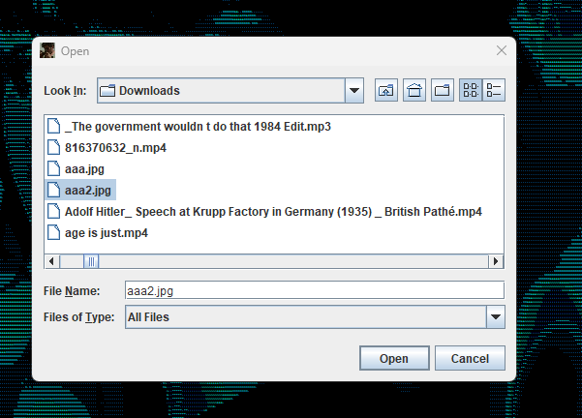

# 5. OUTPUT

## **OUPTUT 1**

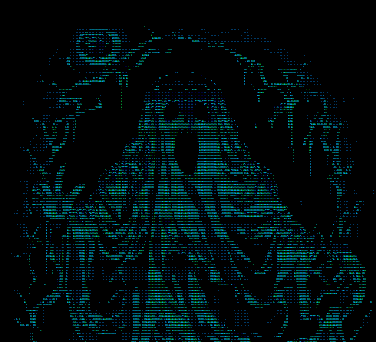

## **OUTPUT 2**

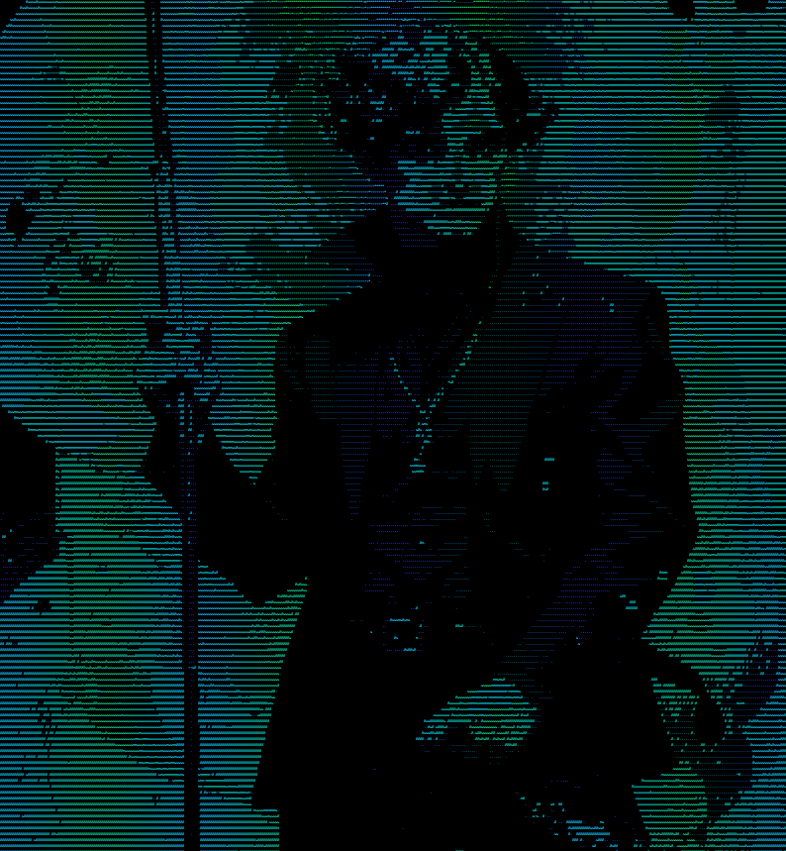

# 6. LICENSE

MIT License   
   
Copyright (c) 2024 DULLAT   
   
Permission is hereby granted, free of charge, to any person obtaining a copy   
of this software and associated documentation files (the "Software"), to deal   
in the Software without restriction, including without limitation the rights   
to use, copy, modify, merge, publish, distribute, sublicense, and/or sell   
copies of the Software, and to permit persons to whom the Software is   
furnished to do so, subject to the following conditions:   
   
The above copyright notice and this permission notice shall be included in all   
copies or substantial portions of the Software.   
   
THE SOFTWARE IS PROVIDED "AS IS", WITHOUT WARRANTY OF ANY KIND, EXPRESS OR   
IMPLIED, INCLUDING BUT NOT LIMITED TO THE WARRANTIES OF MERCHANTABILITY,   
FITNESS FOR A PARTICULAR PURPOSE AND NONINFRINGEMENT. IN NO EVENT SHALL THE   
AUTHORS OR COPYRIGHT HOLDERS BE LIABLE FOR ANY CLAIM, DAMAGES OR OTHER   
LIABILITY, WHETHER IN AN ACTION OF CONTRACT, TORT OR OTHERWISE, ARISING FROM,   
OUT OF OR IN CONNECTION WITH THE SOFTWARE OR THE USE OR OTHER DEALINGS IN THE   
SOFTWARE.